PlayerID | FullName | Photo | Phone number
400630090 | Aaron Doran |  | 0917-119-782
400630140 | Aaron Hughes |  | 0931-806-531
400630330 | Aaron Lennon | 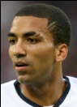 | 0974-405-775
400630363 | Aaron Mokoena | 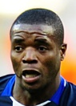 | 0953-881-609
400630397 | Aaron Ramsey |  | 0981-933-500
400630538 | Abdoulaye Faye |  | 0943-213-334
400630579 | Adam Bogdan |  | 0922-039-609
400630637 | Adam Clayton |  | 0988-622-273
400630777 | Adam Johnson |  | 0939-665-072
400630785 | Adel Taarabt |  | 0986-756-161
400630868 | Afonso Alves | 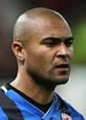 | 0966-126-706
400630876 | Alan Hutton |  | 0926-100-487
400630892 | Alan Judge |  | 0924-373-228
400630900 | Alan Smith |  | 0969-881-155
400630934 | Alberto Riera |  | 0934-552-273
400631056 | Alex da Costa | 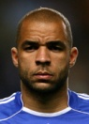 | 0948-787-731
400631239 | Alexan Billong |  | 0983-719-951
400631411 | Ali Al Habsi | 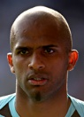 | 0956-864-864

